**LOCKER Project Source code**

**//Main Method of locker project**

**import** java.io.File;

**import** java.io.FileInputStream;

**import** java.io.FileOutputStream;

**import** java.io.IOException;

**import** java.io.ObjectInputStream;

**import** java.io.ObjectOutputStream;

**import** java.nio.file.Files;

**import** java.nio.file.NoSuchFileException;

**import** java.nio.file.Paths;

**import** java.util.Scanner;

**public** **class** LockerMain {

**public** **static** **void** main(String[] args) **throws** NoSuchFileException {

//String s;

**int** a;

**int** b;

**int** c =3;

@SuppressWarnings("unused")

String s, s1,s2;

// String dirname = "look";

// File d = new File(dirname);

// Create directory now.

// d.mkdirs();

ObjectInputStream stream = **null**;

ObjectInputStream stream1 = **null**;

**try** {

stream = **new** ObjectInputStream(**new** FileInputStream("look/Ramlal.txt"));

stream1 = **new** ObjectInputStream(**new** FileInputStream("look/Mohan.txt"));

Customer customer = (Customer) stream.readObject();

Student student = (Student) stream1.readObject();

//System.out.println("File list is shown in Locker Folder");

//System.out.println(customer);

//System.out.println(student);

} **catch** (IOException | ClassNotFoundException e) {

e.printStackTrace();

} **finally**{

**if**(stream!=**null**&&stream1!=**null**) {

**try** {

stream.close();

stream1.close();

} **catch** (IOException e) {

e.printStackTrace();

}

}

}

System.***out***.println("Welcome to LockedMe.com");

System.***out***.println("Kalpana Uttam Rathod");

System.***out***.println("Full Stack Java Developer");

@SuppressWarnings("resource")

Scanner sc = **new** Scanner(System.***in***);

System.***out***.println("Enter 1.File list");

System.***out***.println("Enter 2..Operatin on Files");

System.***out***.println("Enter 3..Close an Application");

a = sc.nextInt();

//s = sc.nextLine();

**if** (a==1) {

System.***out***.println("File list is shown in Locker Folder");

}

**else** **if** (a==2) {

//System.out.println("You entered option 2. ");

@SuppressWarnings("resource")

Scanner sc1 = **new** Scanner(System.***in***);

System.***out***.println("Enter 1. Add file");

System.***out***.println("Enter 2. Delete file");

System.***out***.println("Enter 3. Search file");

b = sc1.nextInt();

**if**(b==1) {

//System.out.println("You enter option 1. add file");

@SuppressWarnings("resource")

Scanner sc2 = **new** Scanner(System.***in***);

System.***out***.println("You enter file name");

s =sc2.nextLine();

Student student1 = **new** Student(51, "mohan", 8);

ObjectOutputStream stream2 = **null**;

**try** {

stream2 = **new** ObjectOutputStream(**new** FileOutputStream(s));

stream2.writeObject(student1);

System.***out***.println("File is created, look in Locker folder");

} **catch** (IOException e) {

e.printStackTrace();

} **finally**{

**if**(stream!=**null**) {

**try** {

stream.close();

} **catch** (IOException e) {

e.printStackTrace();

}

}

}

}

**else** **if**(b==2) {

//System.out.println("You enter option 2. Delete file");

//@SuppressWarnings("resource")

Scanner sc3 = **new** Scanner(System.***in***);

System.***out***.println("enter file name");

s1 =sc3.nextLine();

// String fileName = "kalpana.txt";

**try** {

Files.*delete*(Paths.*get*(s1));

System.***out***.println("File deleted look in locker folder");

}

**catch** (IOException e) {

System.***out***.println("incorrect file");;

}

}

**if**(b==3) {

//System.out.println("You enter option to search file");

String[] StringArray ={"kalpana","rathod.txt","kalpanarathod.txt"};

**int** index;

**boolean** found=**false**;

//@SuppressWarnings("resource")

Scanner sc4 = **new** Scanner(System.***in***);

System.***out***.println("enter file name");

s2 =sc4.nextLine();

**for**(index=0; index<StringArray.length; index++) {

**if**(s2.equals(StringArray[index])) {

found=**true**;

//System.out.print(StringArray[index] + " ");

**break**;

}

}

**if**(found) {

System.***out***.println("file is found ");

System.***out***.println("file is:"+s2);;

}

**else** {

System.***out***.println("file not found:"+s2);

}

}

}

**if**(a==3) {

//System.out.println("You entered option to close an application");

System.*exit*(c);

}

}

}

Source code for writing data in file

//Class student

**import** java.io.Serializable;

**public** **class** Student **implements** Serializable {

**private** **int** rolleNo;

**private** String name;

**private** **int** studentClass;

**public** Student() {}

**public** Student(**int** rolleNo, String name, **int** class1) {

**this**.rolleNo = rolleNo;

**this**.name = name;

studentClass = class1;

}

**public** **int** getRolleNo() {

**return** rolleNo;

}

**public** **void** setRolleNo(**int** rolleNo) {

**this**.rolleNo = rolleNo;

}

**public** String getName() {

**return** name;

}

**public** **void** setName(String name) {

**this**.name = name;

}

**public** **int** getstudentClass() {

**return** studentClass;

}

**public** **void** setClass(**int** class1) {

studentClass = class1;

}

@Override

**public** String toString() {

**return** "Student [rolleNo=" + rolleNo + ", name=" + name + ", studentClass=" + studentClass + "]";

}

}

//Main method

**import** java.io.FileOutputStream;

**import** java.io.IOException;

**import** java.io.ObjectOutputStream;

**public** **class** studentWriteDemo {

**public** **static** **void** main(String[] args) {

Student student = **new** Student(51, "mohan", 8);

ObjectOutputStream stream = **null**;

**try** {

stream = **new** ObjectOutputStream(**new** FileOutputStream("look/Mohan.txt"));

stream.writeObject(student);

System.***out***.println("Customer object written in file");

} **catch** (IOException e) {

e.printStackTrace();

} **finally**{

**if**(stream!=**null**) {

**try** {

stream.close();

} **catch** (IOException e) {

e.printStackTrace();

}

}

}

}

}

**//Class CUSTOMER**

**import** java.io.Serializable;

**public** **class** Customer **implements** Serializable{

**private** **int** customerId;

**private** String customerName;

**private** String customerAddress;

**public** Customer() {}

**public** Customer(**int** customerId, String customerName, String customerAddress) {

**this**.customerId = customerId;

**this**.customerName = customerName;

**this**.customerAddress = customerAddress;

}

**public** **int** getCustomerId() {

**return** customerId;

}

**public** **void** setCustomerId(**int** customerId) {

**this**.customerId = customerId;

}

**public** String getCustomerName() {

**return** customerName;

}

**public** **void** setCustomerName(String customerName) {

**this**.customerName = customerName;

}

**public** String getCustomerAddress() {

**return** customerAddress;

}

**public** **void** setCustomerAddress(String customerAddress) {

**this**.customerAddress = customerAddress;

}

@Override

**public** String toString() {

**return** "Customer [customerId=" + customerId + ", customerName=" + customerName + ", customerAddress="

+ customerAddress + "]";

}

}

**//MAIN Method**

**import** java.io.FileOutputStream;

**import** java.io.IOException;

**import** java.io.ObjectOutputStream;

**public** **class** CustomerWriteDemo {

**public** **static** **void** main(String[] args) {

Customer customer = **new** Customer(1, "Ramlal", "Delhi");

ObjectOutputStream stream = **null**;

**try** {

stream = **new** ObjectOutputStream(**new** FileOutputStream("look/Ramlal.txt"));

stream.writeObject(customer);

System.***out***.println("File is created");

} **catch** (IOException e) {

e.printStackTrace();

} **finally**{

**if**(stream!=**null**) {

**try** {

stream.close();

} **catch** (IOException e) {

e.printStackTrace();

}

}

}

}

}

Program Output

1.Before user input

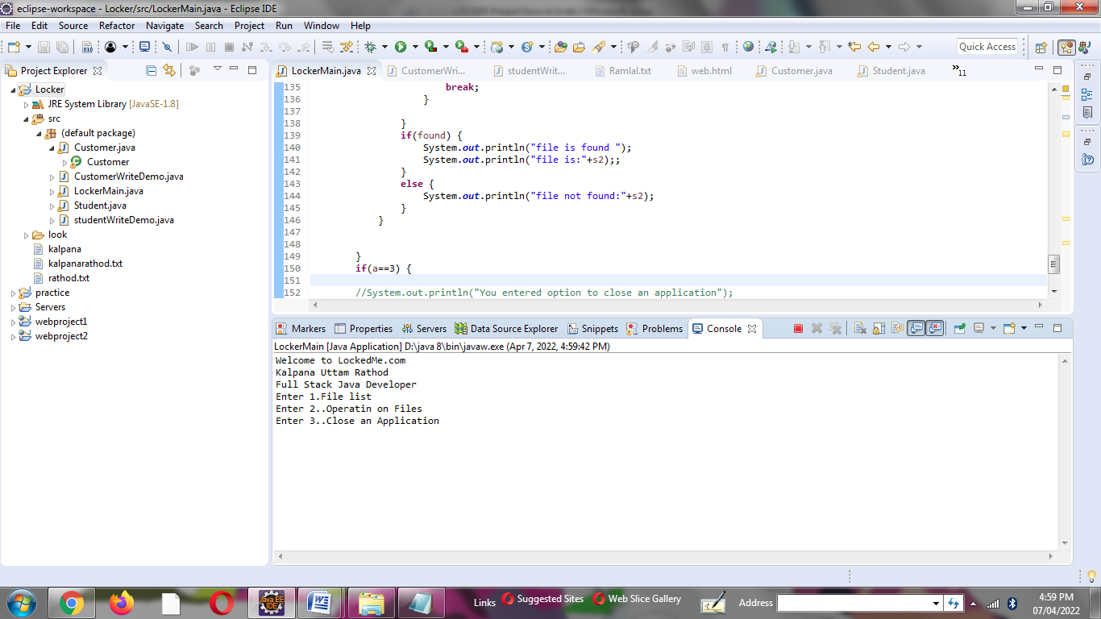

2.If user input is 1

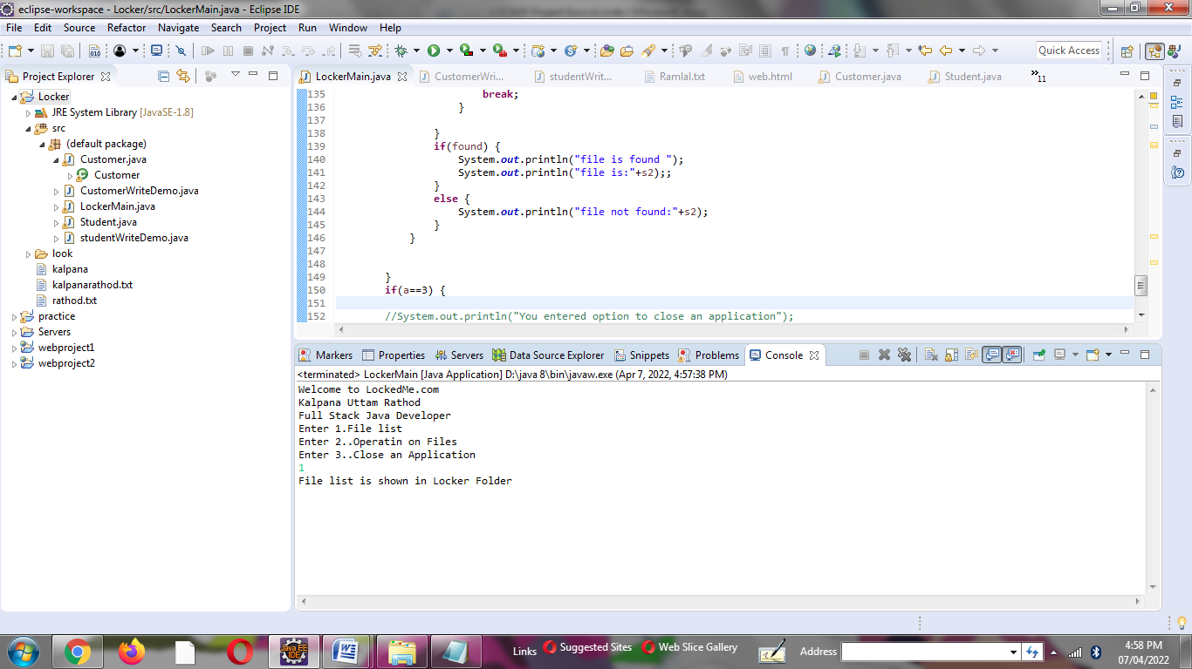

3.If user input is 2

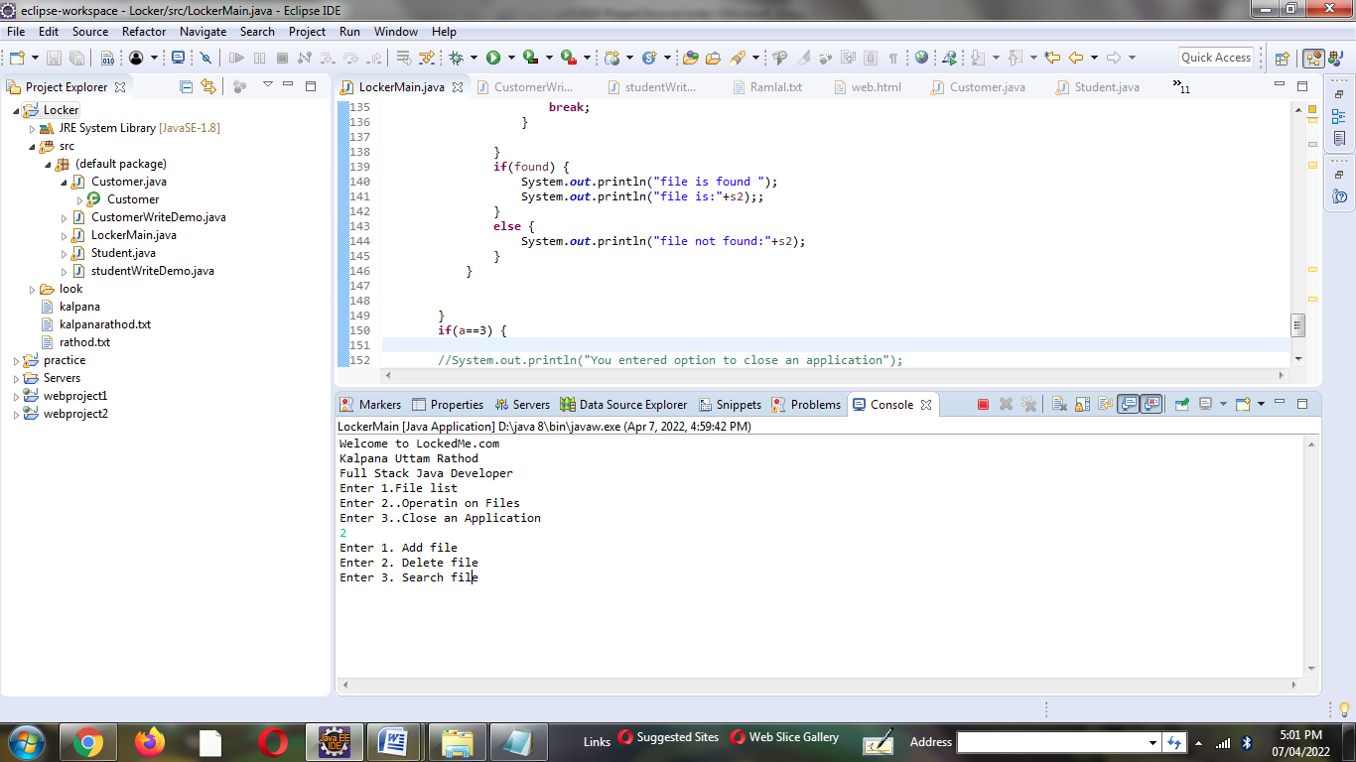

4.If user input is 2. And next sub-input is 1.

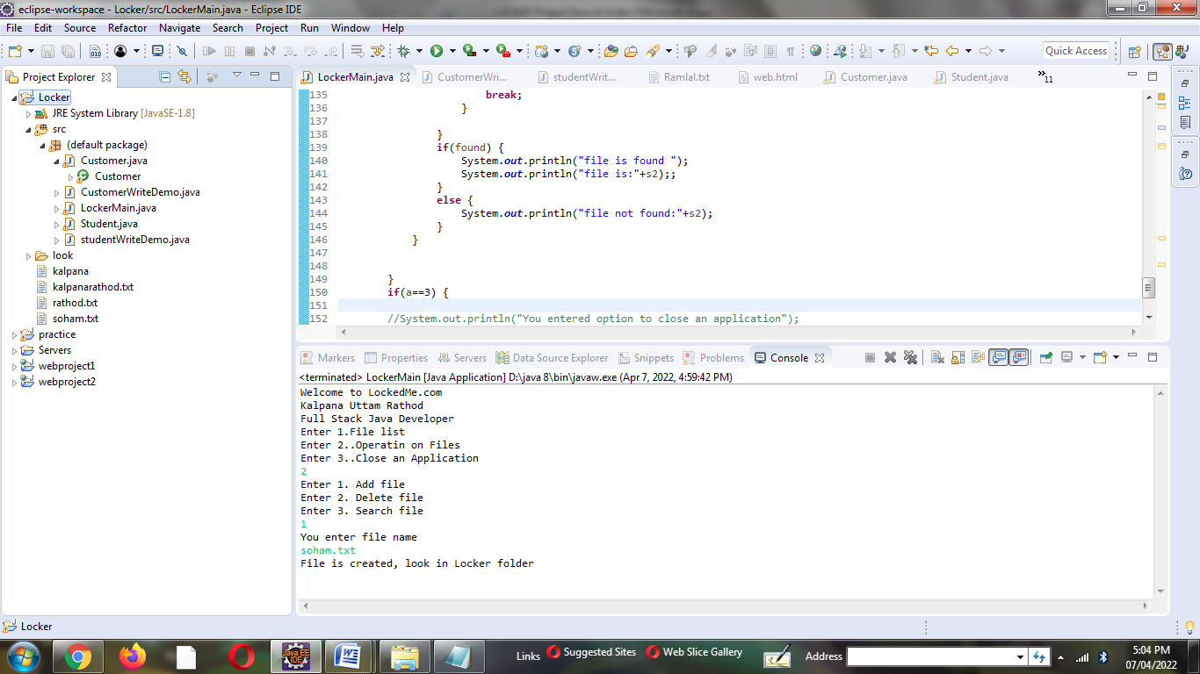

5.if user input is 2. And next sub-input is 2.

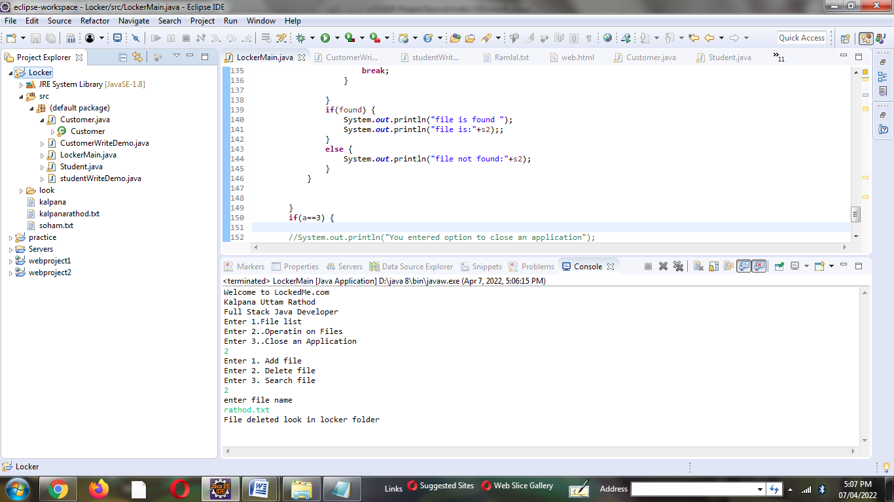

6. If user input is 2 and next sub-input is 3.

Case 1. File not found.

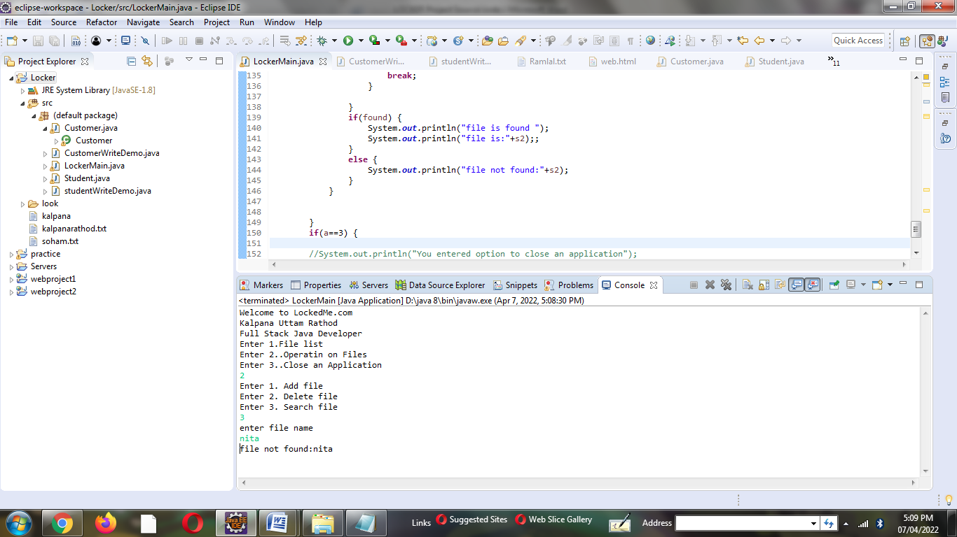

Case 2. File found

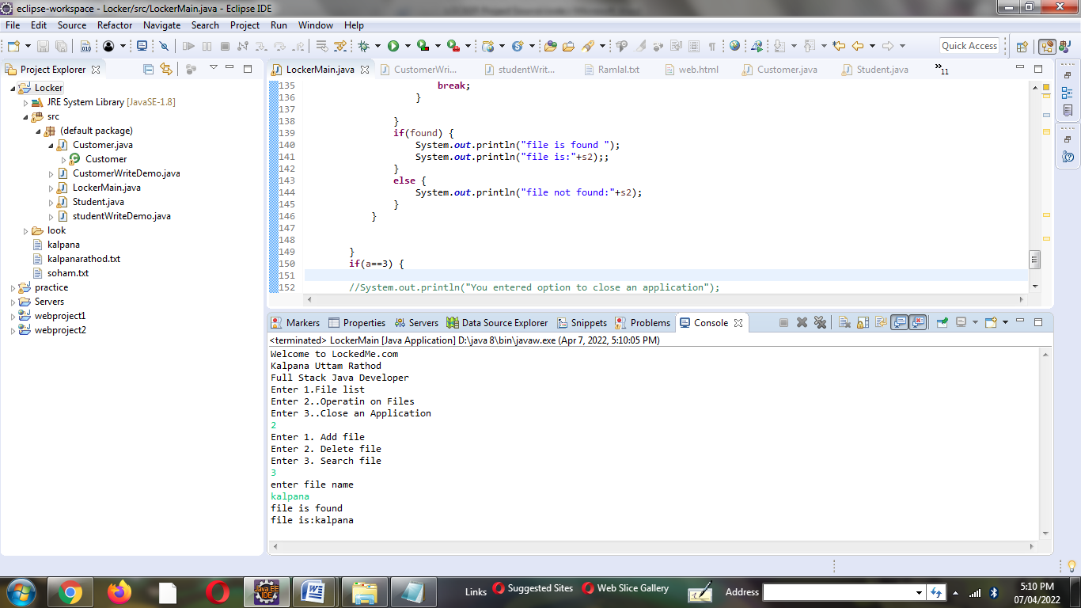

7. if user input is 3.

